ITN 263 – Project Part 1: Network Design

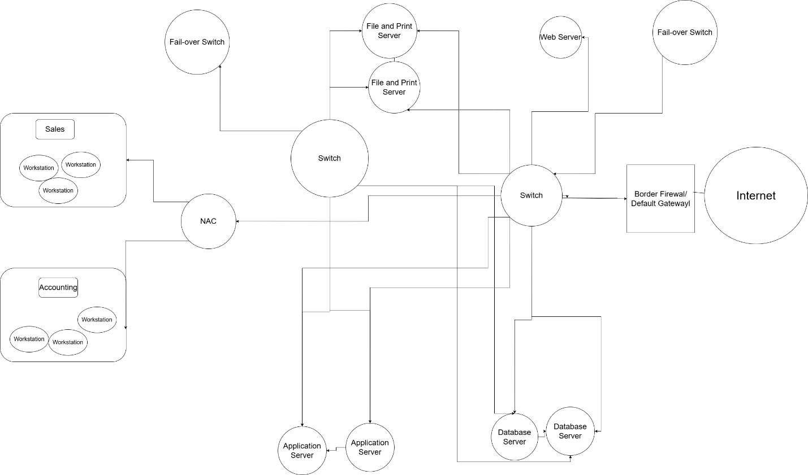

To create the best network design that ensures the security of internal access while retaining public website availability, I first created a network topology of the physical and logical connections in the network to see where the layout of the network is. In this topology diagram, we can see that from the internet, traffic is filtered through a border firewall as the first line of defense. This firewall ensures that unwanted and known malicious traffic is blocked access to the network to prevent intrusions and malicious activity from happening on the network which enhances its security. After passing through the firewall, traffic is diverted to various sections of the network. The switch is physically connected to the servers and workstations through ethernet cables. There is also another switch that physically connects the database, application, and file and print servers together to allow for seamless communication. To ensure that communications are available 24/7, each switch is connected to a fail-over switch which will provide redundancy in case the switch fails. Once a switch becomes offline, the fail-over switch will immediately take over its responsibilities to ensure that communications are available until the main switch comes back online. Finally, there is a network access control device that prevents any workstations without the proper security measures like updated anti-virus and native firewall from connecting the network to reduce the chances of malware making it onto the network. The workstations are also logically separated into a sales department and an accounting department to divide traffic that is meant for each group.

In the network diagram, I have mapped the connections made in the network while also adding enchantments that will increase the security of the network as a whole. As traffic comes into the network from the internet, it is first filtered through a border firewall as the first line of defense. This firewall acts to prevent any traffic we have made rules to block because it is known to be malicious or unwanted. After going through the firewall, an intrusion detection device identifies malicious activity that may have gotten through the firewall while alerting security personnel to allow for efficient eradication of this activity. There is also an intrusion prevention device that detects and eradicates malicious activity on its own. After going through these security devices, traffic is allowed into the public web server which is before another firewall that isolates the web server to not allow any threats to leak out onto the network. From this internal firewall, traffic is allowed to the switch which directs traffic to the servers and workstations. There is also another switch that connects each server to each other to allow for better communication. Also, to provide redundancy and allow for 24/7 communication, there will be a fail-over switch for both switches to help continue communications in case they were to go down for any reason.

I think it would be more beneficial to the company to upgrade to IPv6 rather than continue with IPv4 because there has been unprecedented growth that is leading to the client-facing staff being doubled. IPv6 has a much larger address space which allows every new and old staff member to have a unique IP address without needing to use network address translation to find an open IP address. It also provides substantially better security than IPv4 mainly through IPSec which provides encryption and authentication of packets sent through the internet. IPv6 is also more efficient than IPv4 which allows for better performance because it has a simpler header that makes routing and processing of packets more efficient.

Citations:

Stewart, James Michael, and Denise Kinsey. *Network Security, Firewalls, and VPNS*. Jones and Bartlett Learning, 2021.

“Why IPv6 Matters: Benefits and Beyond in 2024.” *Toxigon.Com*, 13 Dec. 2024, toxigon.com/understanding-ipv6-and-its-benefits.